Assignment-15

Problem Statement: Create a serverless computing service
STEP 1-> Search for Lambda and click on it.
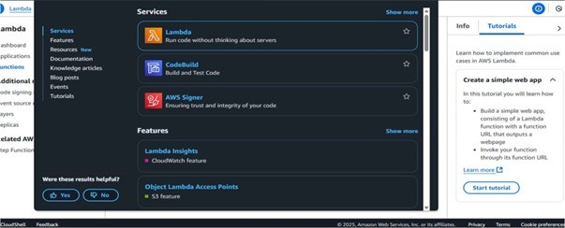
STEP 2-> Click on Create a function button.
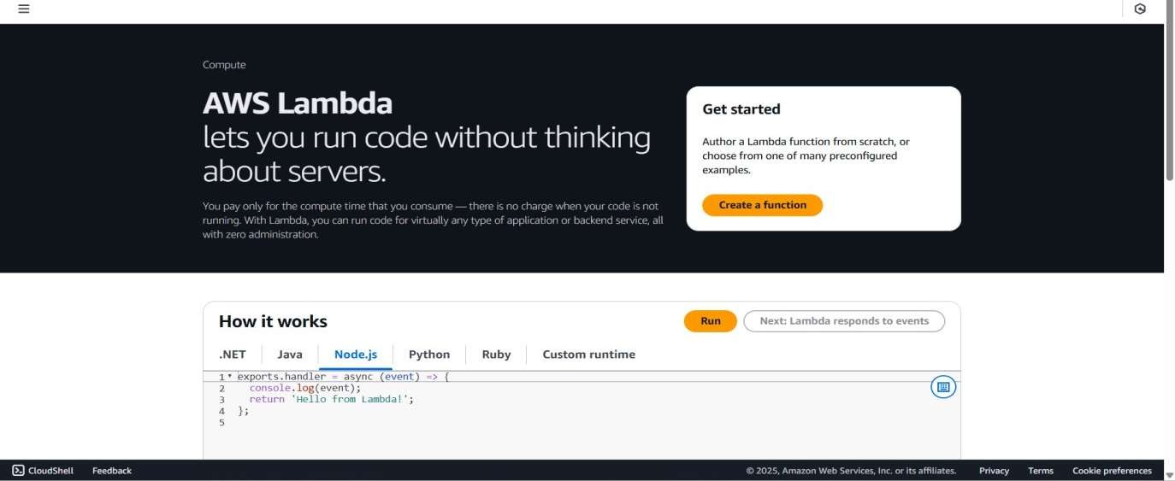
STEP 3-> Give a name to the function and under runtime select Python.
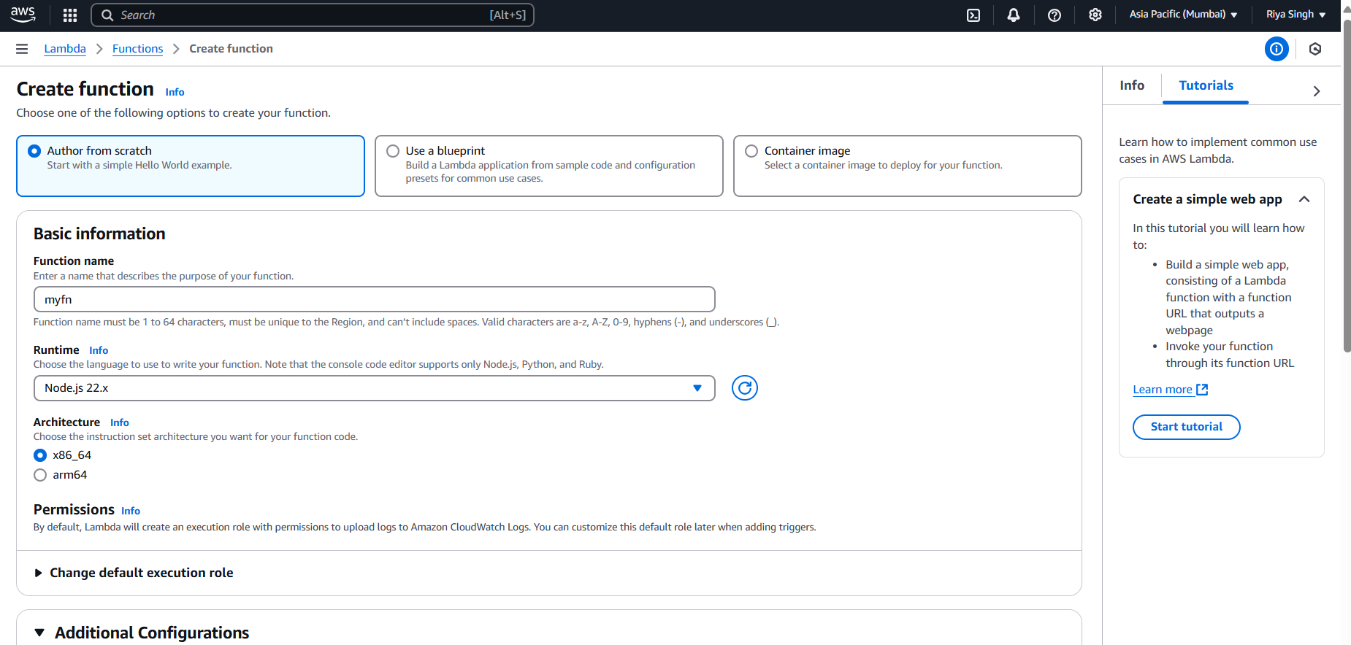

STEP 4-> Under the Advanced settings, check the Enable Function URL checkbox & under Auth type, select NONE. Then click on Create Function.

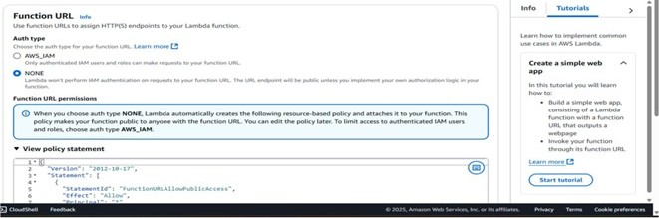
STEP 5-> The function has been created. Now copy the function URL and paste it on a new tab.
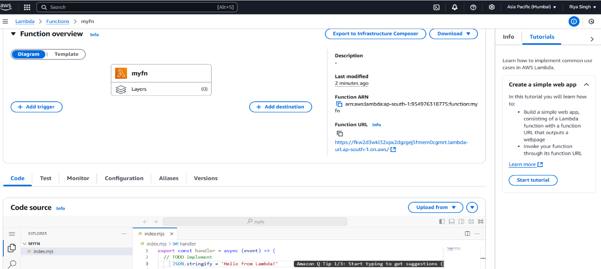

STEP 6-> The following output should be obtained.

